**Animals Scheme of Work – ELC English**

*Lesson 1:* understanding animal classification

*Skills:* Reading – deduction; summary.

*Practice:* matching exercise; cloze exercise

Starter:

In this lesson, we will be improving our deduction skills. Have you heard this word before? Does anybody know what it means?

Deduction means using the clues we have to work something out.

Look at the pictures below and try to guess what jobs each of the people might do. What clues helped you work it out?



Job:



Job:



Job:



Job:

Main Activity:

There are lots of different classifications, or groups, of animals. How many can you think of?

Clues:

F _ _ _

M _ _ _ _ _

B _ _ _

A _ _ _ _ _ _ _ _

Complete the flow chart below by writing the name of an animal that fits the description in each of the four boxes at the bottom of the page (or you could draw a picture).

Does it have two legs?

NO

YES

Can it fly?

Does it have claws?

YES

NO

YES

NO

Amphibians and mammals are two different classifications, or types, of animal.

Draw a line between the descriptions of amphibians on the left to match the similar description of mammals on the right.

|  |
| --- |
| Mammals |
| They give birth to live young. |
| They have fur or hair. |
| Most live on land. |
| They are warm blooded. |

|  |
| --- |
| Amphibians |
| They live on land and in water. |
| They lay their eggs in water. |
| They are cold blooded. |
| They have smooth skin. |

How did you work out how to match up each pair?

And a final deduction… can you find the correct word to fit in the gaps in the text below:

Birds breathe help feet keep their

Fish have gills to help them ______________ , fins to _____________ them swim and scales to protect _____________ bodies.

___________ have beaks to help them eat, wings to help them fly, claws on their __________ to help them grip and feathers to help _____________ them warm.

Plenary:

Write down three things that you have learned about animals today.

*Lesson 2:* Elephant Facts (1)

*Skills:* Reading – retrieval; selection.

*Practice:* labelling; find and copy; using bullet points.

Starter:

In this lesson, we will be improving how we find information in texts to show we have understood it. This is called retrieval. Does it sound like any other words you know?

Clue:

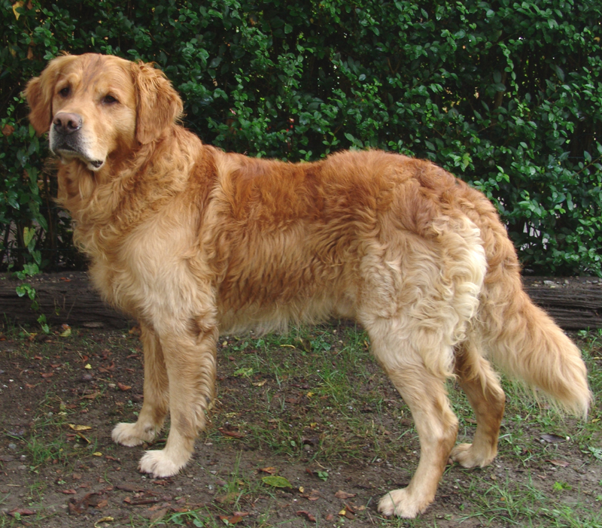

Do you know what type of dog this is?

Do you know what job it does to help people?

Just like the retriever, you will be fetching (pieces of information) from a fact file about elephants.

Read the first two paragraphs of the fact file. Underline or highlight the words in the paragraphs that describe the different parts of the elephant. Label this picture of an elephant using the describing words from the text.

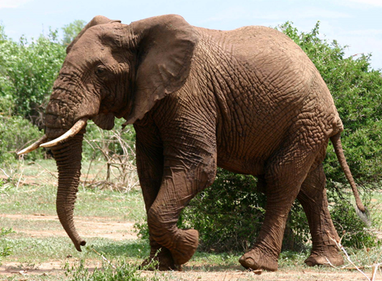

Fact File

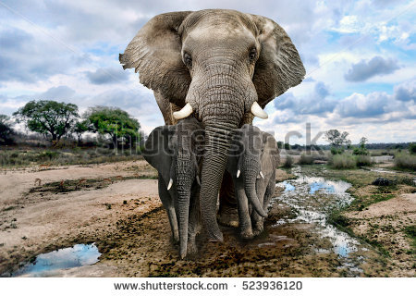

Elephants

The elephant is the largest living land mammal. Elephants live in parts of Africa and Asia. Elephants have massive bodies and heads. They have thick legs that look like tree trunks. They have short padded feet with toes that have big nails. They have grey skin which is loose, tough, and thick.

Elephants do not have much hair. Their thin tails have a little tuft of hair on the end. An elephant’s trunk reaches nearly to the ground. It is used for picking up food, feeding from trees and drawing up water. Elephants drink by sucking water into the trunk and squirting it into the mouth. They also use the trunk to spray themselves with water and with dust when they are hot. The large, thin, floppy ears help keep the elephant cool. It will flap its ears when it is overheated.

Elephants feed on fruits, leaves, shoots, and tall grasses. They consume hundreds of kilograms of food a day and drink up to 190 litres of water. They have no fixed living place but travel about in herds of up to 100 animals, led by a young, strong male.

An elephant’s lifespan is usually 60 or 70 years. Elephants walk at a pace of about 4 miles per hour and can charge at speeds of 30 miles per hour. They cannot jump but they swim very well.

Now let’s test how good your retrieval skills are! Read all of the fact file and try to find the answers to these questions.

1. Find and copy **three** things elephants eat:
   * …………………………………………………………………………………………
   * …………………………………………………………………………………………
   * …………………………………………………………………………………………
2. How much water can an elephant drink in a day?

………………………………………………………………………………………………….

1. Write **two** things that an elephant does to keep cool?
   * …………………………………………………………………………………………
   * …………………………………………………………………………………………

Plenary:

With your partner, and without looking at your fact files, take it in turns to tell each other one piece of information you have learnt today about elephants – see who can remember the most.

*Lesson 3:* Elephant Facts (2)

*Skills:* Reading – retrieval; scanning.

*Practice:* multiple choice questions.

Starter:

What is a multiple choice question?

1. You choose a question to answer from a list.
2. You choose the correct answer from four or five different choices.
3. You choose lots of answers and hope one of them is right.
4. There might be more than one correct answer for you to choose.

Some multiple choice questions are simple retrieval questions. What does ‘retrieve’ mean?

1. To go and fetch something
2. To explain in detail
3. To work something out
4. To write in your own words

How did you work out your answer?

Main Activity:

Read again the elephant fact file from last lesson and try to answer these questions.

1. Tick **two** words below that are used to describe an elephant’s ears.
2. floppy
3. hairy
4. little
5. dusty
6. thin
7. fat
8. How fast do elephants walk? Tick the correct box.
9. 4 miles an hour
10. 10 miles an hour
11. 30 miles an hour
12. 60 miles an hour
13. How long do elephants usually live? Tick the correct box.
14. 30 years
15. 60 years
16. 90 years
17. 100 years

Plenary:

Put into order these ideas for helping you answer multiple choice questions. The first idea should be the one you think is the most helpful to you.

**Think of other words that sound similar**

**Get rid of clearly wrong answers**

**Understand words in a sentence**

**Re-read the text to make sure that you understand**

**Scan the text to find information quickly**

**Find key words in the question to lead you to the right part of the text**

*Lesson 4:* Habitats and Research

*Skills:* Reading – scanning; selection; research.

*Practice:* independent, guided research ahead of Communication Practical Assessments; Functional Writing.

Starter:

Think – pair – share: What do living things need? Try to think of three things with your partner. You might want to think about people, animals and plants.

1. Food 2. Water 3. Air 4. Room to grow)

All of these things come from where we live. This is called a ‘habitat’.

What is your habitat? Do you have all four of these things?

Now think about what you learnt from the fact file about elephants. What do you think an elephant’s habitat is like? Describe it.

Main Activity:

Today you are going to research an animal of your choice using books and the internet. You will write a fact file like the one you read about the elephant. ‘Research’ does not mean ‘copying’ so you need to make sure that you read and understand the information about your animal before you write it in your fact file.

You may use the sentence starters below to help you scan to find different pieces of information:

***FACT FILE***

My animal is______________________________________________

Its classification is__________________________________________

It lives___________________________________________________

My animal’s habitat is ______________________________________

which gives it_____________________________________________

The climate where it lives is _________________________________

My animal’s body is covered with ____________________________

This helps it because _______________________________________

________________________________________________________

Here are some things my animal eats:

* ____________________________________________________
* ____________________________________________________
* ____________________________________________________

My animal is prey for ______________________________________

To protect itself it has / uses _________________________________

This is what my animal looks like:

Plenary:

Write down three interesting facts about your animal (without naming it). Read them to your partner and see if they can guess what your animal is.

*Lesson 5:* Sentences

*Skills:* Writing – punctuating sentences; using conjunctions.

*Practice:* Functional Writing.

Starter:

How many sentences are there in this paragraph? Underline each one.

The elephant is the largest living land mammal. Elephants live in parts of Africa and Asia. Elephants have massive bodies and heads. They have thick legs that look like tree trunks. They have short padded feet with toes that have big nails. They have grey skin which is loose, tough, and thick.

How do you know what makes a sentence?

If we put each sentence on a new line it is easier to see that each one starts with a capital letter and ends with a full stop.

The elephant is the largest living land mammal.

Elephants live in parts of Africa and Asia.

Elephants have massive bodies and heads.

They have thick legs that look like tree trunks.

They have short padded feet with toes that have big nails.

They have grey skin which is loose, tough, and thick.

You will also notice that each of these sentences makes sense by itself; we don’t need any extra information in order to understand it.

Each of the sentences has one piece of information in it. Sometimes this can get boring if we write or speak like this all the time. Try talking to your partner for one minute only using sentences that have one piece of information in them.

We could try joining some of our sentences to make them more interesting for a reader or listener.  
What kinds of words might help us do this?

Think about how we could join these sentences to make one sentence that has the same two pieces of information in it.

The elephant is the largest living land mammal.

Elephants live in parts of Africa and Asia.

Did you think about joining the sentences like this?

The elephant is the largest living land mammal and they live in parts of Africa and Asia.

OR

Elephants live in parts of Africa and Asia and are the largest living land mammal.

Which is the word that helps us join the two sentences?

What else did we need to change in to make one sentence?

Read these simple sentences about elephants. They are quite boring!

* Elephants walk at a pace of about 4 miles per hour.
* Elephants can charge at speeds of 30 miles per hour.

Join these two sentences together to make one more interesting sentence – it still has to have the same information in it!

Now try joining these sentences:

Elephants cannot jump.

Elephants swim very well.

Put these words into the correct column to show what they do in a sentence.

|  |  |  |
| --- | --- | --- |
| **Time** | **Joining** | **Reason why** |
|  |  |  |
|  |  |  |
|  |  |  |
|  |  |  |
|  |  |  |
|  |  |  |

**as**

**because**

**before**

**and**

**when**

**but**

**until**

**after**

**while**

**due to**

**so**

**since**

Now try using different joining words to turn these two sentences into one. Try it three times with a word from each one of the columns.

**+**

The waiter insulted me.

I left the restaurant.

Write down your three different sentences.

Do they all mean the same?

Plenary:

Read the sentence below. Highlight all of the joining words.  
What happens if you use too many joining words?

I was supposed to go to my friend Jim’s house because he wanted to out to play football but I had been tired all day and just wanted to go to bed so I called him and said that I hadn’t been feeling well since PE due to all the sit ups we had to do.

Rewrite the text using full stops instead of some of the joining words. Remember to use capital letters at the start of every new sentence and check your sentences all make sense.

*Lesson 6:* Instruction Writing

*Skills:* using conjunctions to join, provide explanation and reference time/order; present information clearly.

*Practice:* Functional Writing.

Starter:

Look at these safety signs here.

Work out what you think they mean.

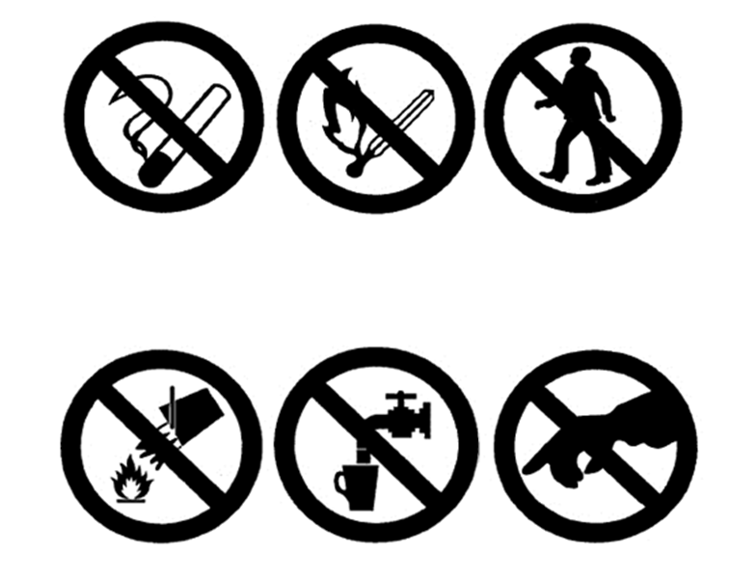

What types of jobs would need similar instructions to keep workers safe?

Main Activity:

Write a list of five things that will help these workers keep safe.

If you need some help getting started, you can finish the sentences below:

1. Wear ______________________________________________.
2. Always _____________________________________________.
3. Carry ______________________________________________.
4. Do not _____________________________________________.
5. Climb ______________________________________________.

Now add reasons to each of your instructions to explain why they are important.  
  
Use the words below to join up your instruction and explanation.

because

in order to

as

due to

so

1. Wear ______________________________________________ in order to __________________________________________.
2. Always _____________________________________________ because ____________________________________________.
3. Carry ______________________________________________ as _________________________________________________.
4. Do not _____________________________________________ due to _____________________________________________.
5. Climb ______________________________________________ so _________________________________________________.

Use the template below to help you write a health and safety leaflet for construction workers.

Plenary:

Write a list of dangers that a zoo keeper might face in their job.

Write three instructions including explanations to help keep them safe. Make sure you are using joining words.

*Lesson 7:* Poop!

*Skills:* Reading – sequencing; Writing – instructions.

*Practice:* Topic Test 2 (Editing and Sequencing); Functional Writing.

Starter: look at the pictures below and number them in the order the events happen.

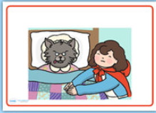

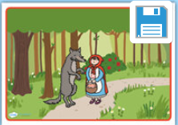

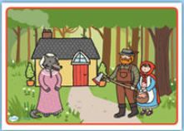

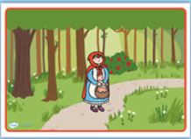

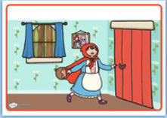

Can you explain why you have put the pictures in the order you have?

Now write a sentence for each picture to tell the story briefly.

Read your sentences again. Are there any words you have used that suggest the order that things happen? For example "firstly" or "after".

If you don't have any of these words in your sentences, rewrite them to include some of the following, or any others you can think of:

Firstly After Then Now

Next As Whilst Before

Main Activity:

Look at the leaflet from The Dogs Trust giving information about clearing up after your dog.

Number the pictures to show the order you so do these things then write instructions for each picture. Remember to use some of the words that help show a sequence.

Plenary:

With your partner, think of three reasons why it is important for people to follow any instructions in the correct order.

You could think about instructions for a fire drill, baking a cake, setting up a new phone, and so on.

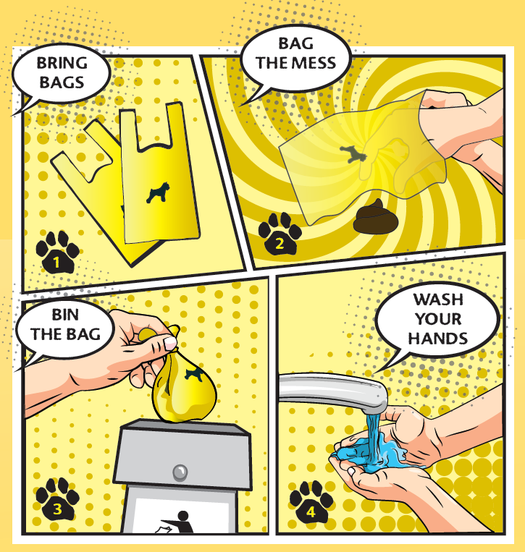

1. ……………………………………………………………………………………………………….

2. ……………………………………………………………………………………………………….

3. ……………………………………………………………………………………………………….

4. ……………………………………………………………………………………………………….

Lesson 8: Poop! (2)

*Skills:* retrieval; deduction; writing imperatives.

*Practice*: Component 1 – Reading Non-fiction and Functional Writing

Starter: Read the heading for an information leaflet we will be exploring in this lesson.



Discuss with your partner what makes this a catchy heading for a leaflet.

"Bag it" and "Bin it" are examples of imperatives. These are sentences that are commands, telling us to do something. An imperative will begin with a verb (a doing or being word).

Write five imperatives starting with the verbs below. Remember you should be telling the reader what to do:

Stop ………………………………………………………………………………………………….

Carry …………………………………………………………………………………………………

Don't …………………………………………………………………………………………………

Write …………………………………………………………………………………………………

Pick ……………………………………………………………………………………………………

Read this leaflet from The Dogs Trust and highlight the verbs (doing or being word) in each of the imperatives.  
  
Why do you think leaflets like this use imperatives?

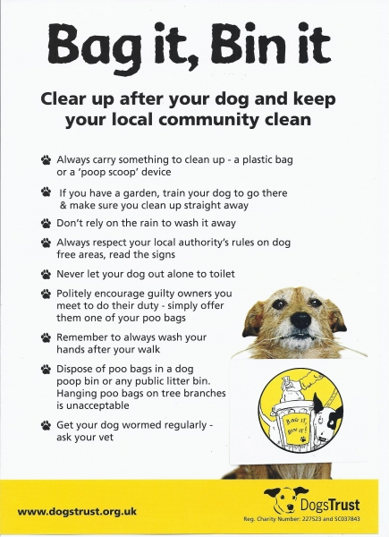

Main Activity:

Write down **three** things you should do if your dog poos when you are out on a walk, according to the leaflet.



What **two** things should you do if you let your dog out for a poo?

1. …………………………………………………………………………………………………
2. …………………………………………………………………………………………………

What do you think the word “dispose” means in this text?

1. Keep hold of something
2. Get rid of something
3. Clean up something
4. Help out with something

What **two** things does the leaflet say you should do to keep you and your dog healthy?

1. …………………………………………………………………………………………….
2. …………………………………………………………………………………………….

Plenary:

Why do you think it is important to clear up after your dog? Try to write three or more reasons.

* ………………………………......................................................................
* ………………………………......................................................................
* ………………………………......................................................................
* ………………………………......................................................................
* ………………………………......................................................................

Lesson 9:

*Skills:* writing to explain; formal language choices; structuring paragraphs.

*Practice*: Component 1 – Functional Writing

Starter: Think – Pair – Share: What is a paragraph?

Think of how you could explain what a paragraph is.

Talk to your partner and come up with a definition you both agree with.

Share your idea with the rest of the class.

A paragraph is a group of sentences about the same idea or topic, same person, same place or same time.

Whenever you are writing about a change to a different idea, person, place or time you should take a new paragraph by starting a new line.

Read the sentences below and try to work out where the writer should have taken a new paragraph.

It was a dark, stormy sky that looked down on Archer Road that Sunday night. The streets were quiet. Even Mr Jones’s car alarm was silent. In a sleeping house, Dave peered out from behind the curtains, waiting for the sign. There it was – across the street. The light from a torch flashed towards him for a second time. Sarah had been planning this for months now. The car was ready for their journey. By 3.30am they had reached the border. This was where their future – their future together – began.

Writing Task:

Write a letter to the local council who looks after our streets. In your letter, explain why it is important that dog owners clean up after their dogs. Persuade the council to do more to encourage people to pick up their dog poo.

Each paragraph should start with a 'topic sentence' that lets the reader know what that paragraph will be about. The rest of the paragraph then explains more about this idea.

What does the topic sentence below tells us the paragraph will be about?

**Dog owners who let their dogs make a mess in the streets are a disgrace.**

Now write the rest of the paragraph.

**Planning Page**

Introduction

*What is the issue that you are writing about?*

*Why you are concerned about this issue?*

First paragraph

*First reason why dog mess is a problem (topic sentence).*

*What problems does this cause?*

*What could be done to help?*

Second paragraph

*Second reason why dog mess is a problem (topic sentence).*

*What happens as a result of this?*

Third paragraph

*Third reason why dog mess is a problem (topic sentence).*

*What problems do people have because of this?*

Fourth Paragraph

*Three things the council should do to encourage dog owners to clear up after their dogs:*



Conclusion

Why is it an important issue?

Why should the council do something?

Plenary:

This is a formal letter so you need to make sure that you have used language that is suitable for an important person that you do not know.

Highlight all the words that you could use in a formal situation.

|  |  |  |  |
| --- | --- | --- | --- |
| Hiya | Dear | sort it out | find a solution |
| See ya | grateful | cheers | assistance |
| I am certain | I reckon | disappointed | have a moan |
| gutted | make a complaint | loads of | a considerable amount |
| prevent | stop | not enough | insufficient |

*Practice Test:* Poop!

*Skills:* Reading – retrieval; deduction/inference; verbal reasoning; extended response. Writing Task – letter to council (planned in previous lesson).

*Practice:* Examination – Sections A&B/Topic Test 1.

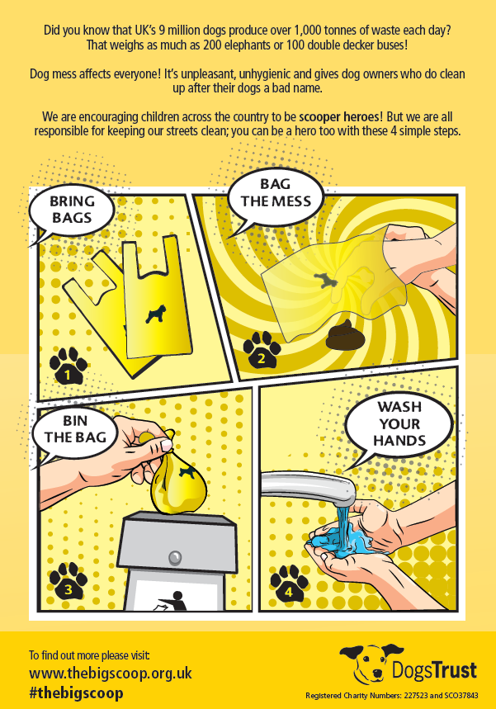

**Answer the questions below to show your understanding of the leaflet.**

1. How many tonnes of dog waste are produced every day in the UK? Tick the correct box. [1]

1. 9 million
2. 1,000
3. 200
4. 100

2. How many dogs are there in the UK? [1]

…………………………………………………………………………………………………………………………

3. Why does the leaflet suggest that dog owners have "a bad name"? [2]

……………………………………………………………………………………………………………………………………………………………………………………………………………………………………………………………………………………………………………………………………………………………………………….

4. What do you think the word "unhygienic" means? Tick the correct box. [1]

1. Nice
2. Clean
3. Loud
4. Dirty

5. How does this leaflet persuade people to clear up dog poop? [10]

You could think about:

* The words the leaflet uses
* The pictures and colours in the leaflet
* Information the leaflet gives.

Mark scheme

1. How many tonnes of dog waste are produced every day in the UK? Tick the correct box. [1]

Award one mark for:

b) 1,000

2. How many dogs are there in the UK? Tick the correct box. [1]

Award one mark for:

9 million (9,000,000/9m)

3. Why does the leaflet suggest that dog owners have "a bad name"? [2]

Award **one mark** for those who state that dog owners do not clear up after their dogs.

Award **two marks** for those who state that it is unfair on dog owners who do clear up after their dogs as people will think all dog owners are responsible for the mess/people think all dog owners are the same in not clearing up mess.

**No marks** can be awarded for those who simply state that dogs poo outside.

4. What do you think the word "unhygienic" means? Tick the correct box. [1]

Award one mark for:

d) Dirty

5. How does this leaflet persuade people to clear up dog poop? [10]

Marks should be awarded according to the banded levels of response (overleaf).

Some points learners may explore:

* Use of rhetorical question to make the reader think about the scale of the problem ("did you know…?")
* The figures/statistics used to show how big the problem is ("9 million"/"1,000 tonnes"/"200 elephants"/"100 double deckers")
* Words that makes us all sound like this is a shared problem ("everyone"/"We"/"we are all responsible"/"our streets")
* Encourages children with the play on 'superhero' ("scooperhero") making children feel like they are doing good
* Easy to follow diagrams to show how simple it is to clear up dog mess
* Word "simple" to describe the process makes it sound easy to do
* Imperatives/commands given to forcefully **tell** people to clear up mess ("bin the bag")
* Makes it sound like a national problem to be solved ("across the country")
* Exclamation marks to suggest shock ("That weighs as much…!")/emphasis ("affects everyone!")
* The colour is bright and cheerful suggesting positivity/attractive to children
* Gives the details of The Dogs Trust to show they are a reliable charity/easy to contact for further details.

|  |  |
| --- | --- |
|  | **Reading and Understanding** |
| **Band 5**  9-10 marks | To those who:   * make inferences and/or deductions supported by textual detail * begin to show awareness of the writers’ craft, choosing relevant supporting examples * show clear understanding through detailed comments |
| **Band 4**  7-8 marks | To those who:   * make simple inferences and/or deductions sometimes supported by textual detail * select relevant examples from texts * provide sustained comments on texts |
| **Band 3**  5-6 marks | To those who:   * make simple inferences and/or deductions * select some material relevant to tasks * express opinions/preferences |
| **Band 2**  3-4 marks | To those who:   * follow the main points in texts * show some understanding at a literal level * make simple comments/observations |
| **Band 1**  1-2 marks | To those who:   * locate one or two points from the text which may having varying degrees of relevance * attempt to make one or two brief and simple comments which may not be accurate. |
| 0 marks | Nothing worthy of credit |

