Locating Unit 2 external assessment.

- WJEC Secure Website
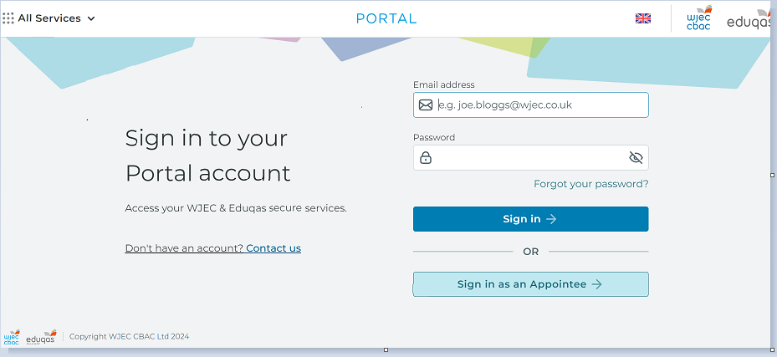
- Click on All Services
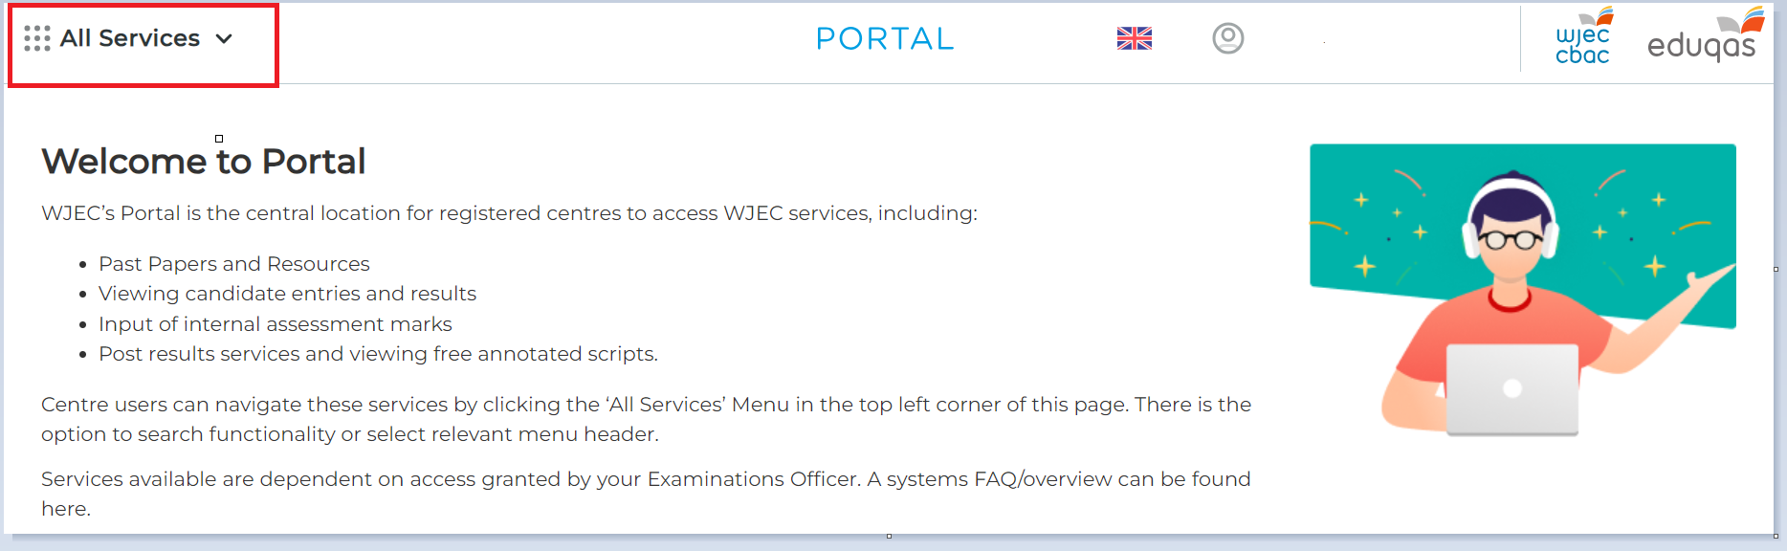
- Select Key information (left hand side) then General > Early papers /Pre-release
